An exhaustive list of the most popular cross-browser testing tools
Published Sep 03, 2021
Cross Browser Testing is one of the most growing needs for software development companies today.
Reasons being –
i. The penetration of the internet in almost every aspect of life
ii. A large number of mobile devices are being manufactured and being used, all around the world. Thus, a mobile app needs to support a large number of devices. At least, the ones that their customers might be using.
iii. To access one website, users have the option of using one out of tonnes of browsers available today.
Thus cross-browser testing – to make sure that a website works on a wide range of browsers, and a mobile app works on all the devices a customer might be using – becomes a necessity.
To cater to the need discussed above – there are multiple testing tools that have been developed with different features.
In this article, we have tried to create an exhaustive list of all such cross-browser testing tools available today. Some of these tools are free, some premium. Some support automated testing, some manual.
Some let you test on real browsers and devices while some make the use of emulators and simulators. In this article, we will try to mention all of those. Do let us know if there is anything else you’d want to know about these tools.
1. Testsigma
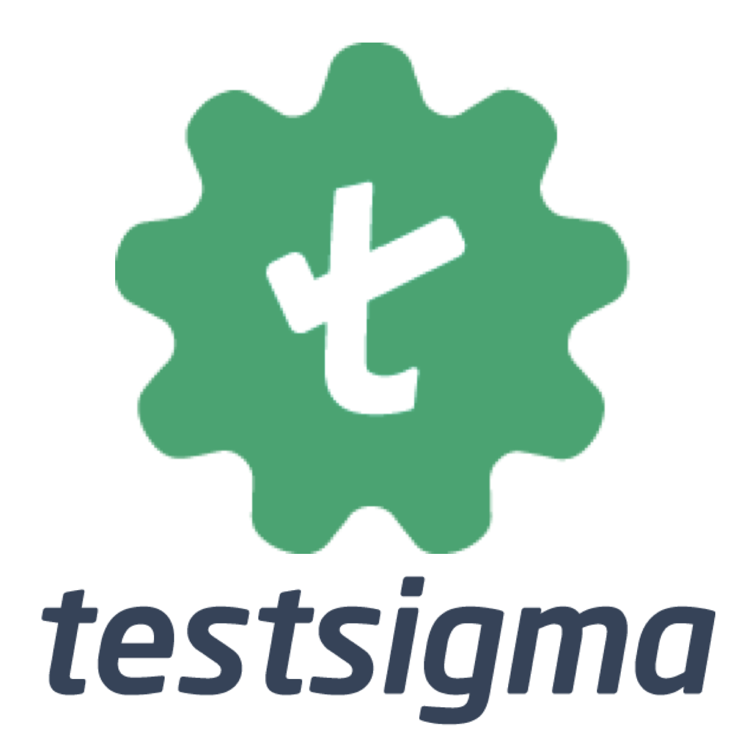
Testsigma is a completely cloud-based automated testing tool that comes integrated with multiple cloud device lab that hosts more than 2000 real browsers and devices.
_ Supports manual testing :_ No
_ Supports automated testing :_ Yes, via simple English for codeless and JAVA for complex customizations
_ Supports testing of a locally hosted website :_ Yes
_ Supports geo-location testing :_ Yes
_ Supports automated visual testing :_ Yes
_ Allows testing on real devices :_ Yes
_ Allows testing on emulators/simulators :_ No
_ Free/Premium :_ Premium, they also have a free trial for 30 days.
Automate your elaborate cross-browser test cases easily with Testsigma
2. LambdaTest

A cloud-based cross-browser testing lab that hosts 2000+ real browsers and devices.
_ Supports manual testing :_ Yes
_ Supports automated testing :_ Yes, via selenium and cypress
_ Supports testing of a locally hosted website: _ Yes
_ Supports geo-location testing :_ Yes
_ Supports automated visual testing :_ Yes
_ Allows testing on real devices :_ Yes for browsers. but iOS and Android devices are hosted on official emulators and simulators
_ Allows testing on emulators/simulators :_ Yes, for iOS and Android devices
_ Free/Premium :_ Premium, they also have a free plan for light manual testing
3. Browserstack
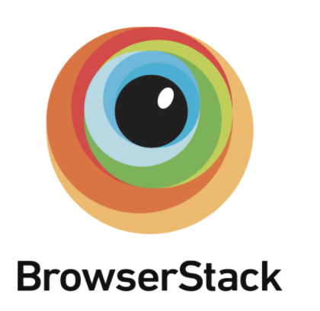
A cloud-based cross-browser testing lab that hosts 2000+ real browsers and devices.
_ Supports manual testing :_ Yes
_ Supports automated testing :_ Yes, via selenium, cypress, and JS Testing.
_ Supports testing of a locally hosted website :_ Yes
_ Supports geo-location testing :_ Yes
_ Supports automated visual testing :_ yes
Allows testing on real devices : Yes
_ Allows testing on emulators/simulators :_ No
_ Free/Premium :_ Premium
4. CrossBrowserTesting (Smartbear TestComplete’s sub product now)

A cloud-based cross-browser testing lab that hosts 2050+ real browsers and devices.
_ Supports manual testing :_ Yes
_ Supports automated testing :_ Yes, via selenium and appium.
_ Supports testing of a locally hosted website :_ Yes
_ Supports geo-location testing :_ Yes
_ Supports automated visual testing :_ yes
_ Allows testing on real devices :_ Yes
_ Allows testing on emulators/simulators :_ No
_ Free/Premium :_ Premium
5. SauceLabs

A cloud-based testing platform that allows continuous testing, automated testing, live testing on the cloud.
Supports manual testing : Yes
Supports automated testing : Yes, via selenium, espresso, appium, xcuitest, cypress, TestCafe, playwright, puppeteer
Supports testing of a locally hosted website : No
Supports geo-location testing : Yes
Supports automated visual testing : yes
Allows testing on real devices : Yes
Allows testing on emulators/simulators : No
Free/Premium: Premium
6. Selenium Box

Selenium Grid can be installed with an enterprise firewall and then can be used for continuous testing and cross-browser testing.
_ Supports manual testing :_ No
_ Supports automated testing :_ Yes, via selenium, appium and playwright
_ Supports testing of a locally hosted website :_ No
_ Supports geo-location testing :_ Yes
_ Supports automated visual testing :_ No, can be programmed and done.
_ Allows testing on real devices :_ Yes
_ Allows testing on emulators/simulators :_ No
_ Free/Premium :_ Premium
7. Ghost Inspector

For automated execution of cross-browser tests. Codeless automation is done via record and playback. Complex scenarios supported via Selenium and Cypress.
_ Supports manual testing :_ No
_ Supports automated testing :_ Yes, via record and playback, selenium, cypress
_ Supports testing of a locally hosted website :_ No
_ Supports geo-location testing :_ Yes
_ Supports automated visual testing :_ Yes.
_ Allows testing on real devices :_ supports responsive testing
_ Allows testing on emulators/simulators :_ No
_ Free/Premium :_ Premium
8. Browsera

This is a tool for automated browser testing, and is good at reporting layout differences and scripting errors on the site. Browsera analyzes and compares the pages for you, using sophisticated algorithms to detect unsightly layout issues.
_ Supports manual testing :_ No
_ Supports automated testing :_ Yes
_ Supports testing of a locally hosted website :_ No
_ Supports geo-location testing :_ No
_ Supports automated visual testing :_ Yes.
_ Allows testing on real devices :_ No
_ Allows testing on emulators/simulators :_ No
_ Free/Premium :_ Premium
9. Perfecto

This is a completely cloud-based testing platform that also supports cross-browser test execution.
_ Supports manual testing :_ Yes
_ Supports automated testing :_ Yes, via scriptless and cypress.
_ Supports testing of a locally hosted website :_ Yes
_ Supports geo-location testing :_ Yes
_ Supports automated visual testing :_ Yes.
_ Allows testing on real devices :_ Yes
_ Allows testing on emulators/simulators :_ Yes
_ Free/Premium :_ Premium
10. Digital.ai continuous testing

This is a testing platform that focuses on enabling continuous testing for enterprises and provides cross-browser testing via the cloud.
_ Supports manual testing :_ Yes
_ Supports automated testing :_ Yes, via selenium grid
_ Supports testing of a locally hosted website :_ Yes
_ Supports geo-location testing :_ No
_ Supports automated visual testing :_ Yes.
_ Allows testing on real devices :_ Yes
_ Allows testing on emulators/simulators :_ Yes
_ Free/Premium :_ Premium
11. Browserling

For quick cross-browser testing (and responsive testing) of your website.
_ Supports manual testing :_ Yes
_ Supports automated testing :_ No
_ Supports testing of a locally hosted website :_ Yes
_ Supports geo-location testing :_ Yes
_ Supports automated visual testing :_ No
_ Allows testing on real devices :_ No, responsive testing supported by resizing
_ Allows testing on emulators/simulators :_ No
_ Free/Premium :_ Premium and a free trial version
12. Functionize

A test automation platform that is cloud-based and comes with test cloud for cross-browser testing.
_ Supports manual testing :_ No
_ Supports automated testing :_ Yes
_ Supports testing of a locally hosted website :_ Yes
_ Supports geo-location testing :_ No
_ Supports automated visual testing :_ Yes
_ Allows testing on real devices :_ No
_ Allows testing on emulators/simulators :_ Yes
_ Free/Premium :_ Premium
13. Mabl

A test automation platform that is cloud-based and comes with a test cloud for cross-browser testing.
_ Supports manual testing :_ No
_ Supports automated testing :_ Yes
_ Supports testing of a locally hosted website :_ Yes
_ Supports geo-location testing :_ No
_ Supports automated visual testing :_ Yes
_ Allows testing on real devices :_ No, though supports responsive testing via chrome emulation
_ Allows testing on emulators/simulators :_ Yes (chrome emulation)
_ Free/Premium :_ Premium
14. TestingBot

A cloud-based test automation platform that supports cross-browser testing.
_ Supports manual testing :_ yes
_ Supports automated testing :_ Yes, via record and playback, selenium, puppeteer, cypress, playwright, appium, TestCafe
_ Supports testing of a locally hosted website :_ no
_ Supports geo-location testing :_ No
_ Supports automated visual testing :_ Yes
_ Allows testing on real devices :_ yes
_ Allows testing on emulators/simulators :_ no
_ Free/Premium :_ Premium, free trial
15. IE NetRenderer

This is a free tool that lets you test the rendering of your website on multiple versions of internet explorer manually.
_ Supports manual testing :_ Yes
_ Supports automated testing :_ No
_ Supports testing of a locally hosted website :_ No
_ Supports geo-location testing :_ No
_ Supports automated visual testing :_ No
_ Allows testing on real devices :_ No
_ Allows testing on emulators/simulators :_ No
_ Free/Premium :_ Free
16. IE Tab

This is available in the form of a chrome extension. Using this tool, you can test your website on different versions of Internet Explorer while being on chrome.
_ Supports manual testing :_ Yes
_ Supports automated testing :_ No
_ Supports testing of a locally hosted website :_ Yes
_ Supports geo-location testing :_ No
_ Supports automated visual testing :_ No
_ Allows testing on real devices :_ No
_ Allows testing on emulators/simulators :_ No
_ Free/Premium :_ Premium
17. Browsershots

A free open-source online web application that will take screenshots of how your web browser looks on different browsers and show them to you.
_ Supports manual testing :_ Yes
_ Supports automated testing :_ No
_ Supports testing of a locally hosted website :_ No
_ Supports geo-location testing :_ No
_ Supports automated visual testing :_ No
_ Allows testing on real devices :_ No
_ Allows testing on emulators/simulators :_ No
_ Free/Premium :_ Premium
18. Ranorex Studio

A test automation tool to automate for desktop, web as well as mobile.
_ Supports manual testing :_ No
_ Supports automated testing :_ Yes, via record and play, C# and VB.net
_ Supports testing of a locally hosted website :_ Yes
_ Supports geo-location testing :_ Yes
_ Supports automated visual testing :_ Yes
_ Allows testing on real devices :_ Yes
_ Allows testing on emulators/simulators :_ Yes
_ Free/Premium :_ Premium
19. Turbo Browser Sandbox

This is like a sandbox of browsers that can be accessed online and can be used for live testing of your website.
_ Supports manual testing :_ Yes
_ Supports automated testing :_ No
_ Supports testing of a locally hosted website :_ No
_ Supports geo-location testing :_ No
_ Supports automated visual testing :_ No
_ Allows testing on real devices :_ No
_ Allows testing on emulators/simulators :_ No
_ Free/Premium :_ Free for 5 users, for more it is Premium
20. Applitools

A test automation platform for testing on the web and mobile, that specializes in visual testing.
_ Supports manual testing :_ No
_ Supports automated testing :_ Yes, via applitools SDK that supports over 50 frameworks and languages
_ Supports testing of a locally hosted website :_ Yes
_ Supports geo-location testing :_ Yes
_ Supports automated visual testing :_ Yes
_ Allows testing on real devices :_ Yes
_ Allows testing on emulators/simulators :_ Yes
_ Free/Premium :_ Free for one user and more than that is Premium
21. Ghostlab

Via Ghostlab, you can connect your browsers and devices and make your website run on them in parallel.
_ Supports manual testing :_ Yes
_ Supports automated testing :_ No
_ Supports testing of a locally hosted website :_ Yes
_ Supports geo-location testing :_ No
_ Supports automated visual testing :_ No
_ Allows testing on real devices :_ Yes
_ Allows testing on emulators/simulators :_ No
_ Free/Premium :_ Free

